AI Assisted Coding
Assignment – 18.3 Name:MOAHMMED ABDUL LAYEEQ
Rollno:2303A52217
Batch:45
Task 1 – Public Transport Route Fare API
Task:
Integrate a Public Transport API to retrieve fare details between two stations.
Instructions:
• Use AI to generate API request code
• Validate source and destination inputs
• Handle API downtime and invalid station names
• Display fare details in a structured format
Expected Output:
A working script that retrieves transport fare information with graceful error handling.

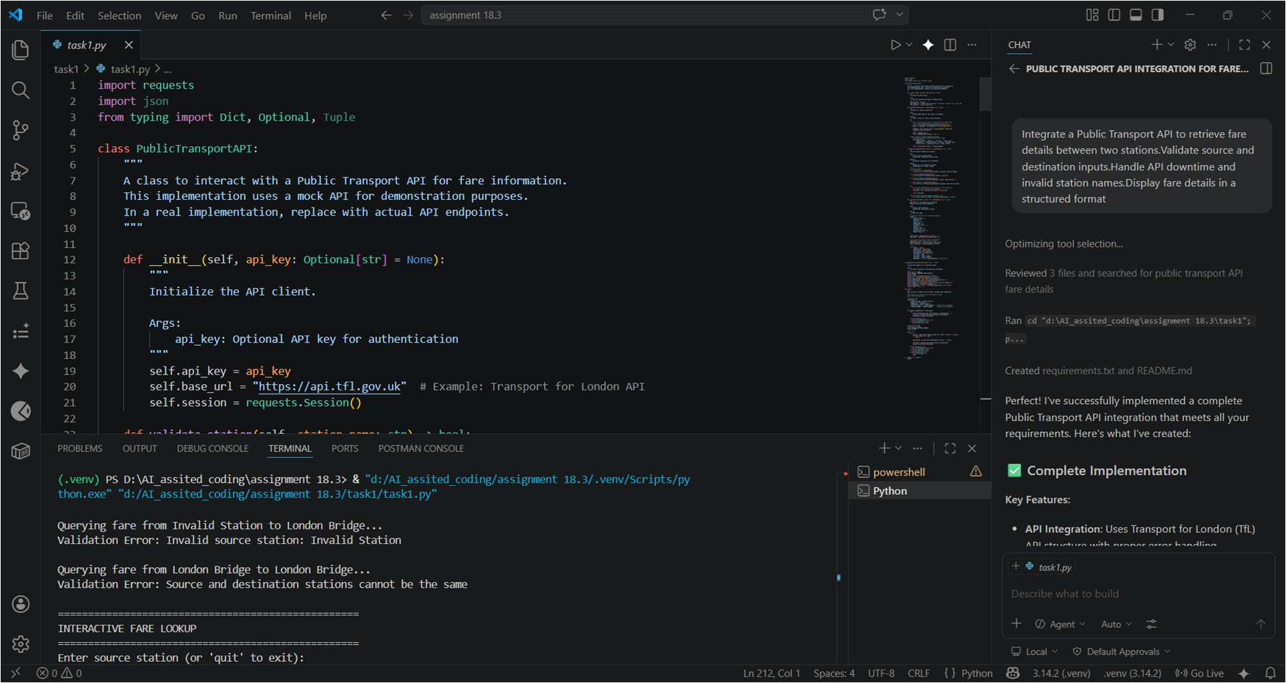
Task 2 – Currency Exchange Rates
Task:
Integrate a Currency Exchange API to convert INR to USD, EUR, and GBP.
Instructions:
• Use AI to generate API request code.
• Validate user input for amount and currency codes. • Implement error handling for invalid responses and API downtime.
• Show conversion results clearly in tabular format.
Expected Output:
• A script that converts INR to multiple currencies with graceful error handling.

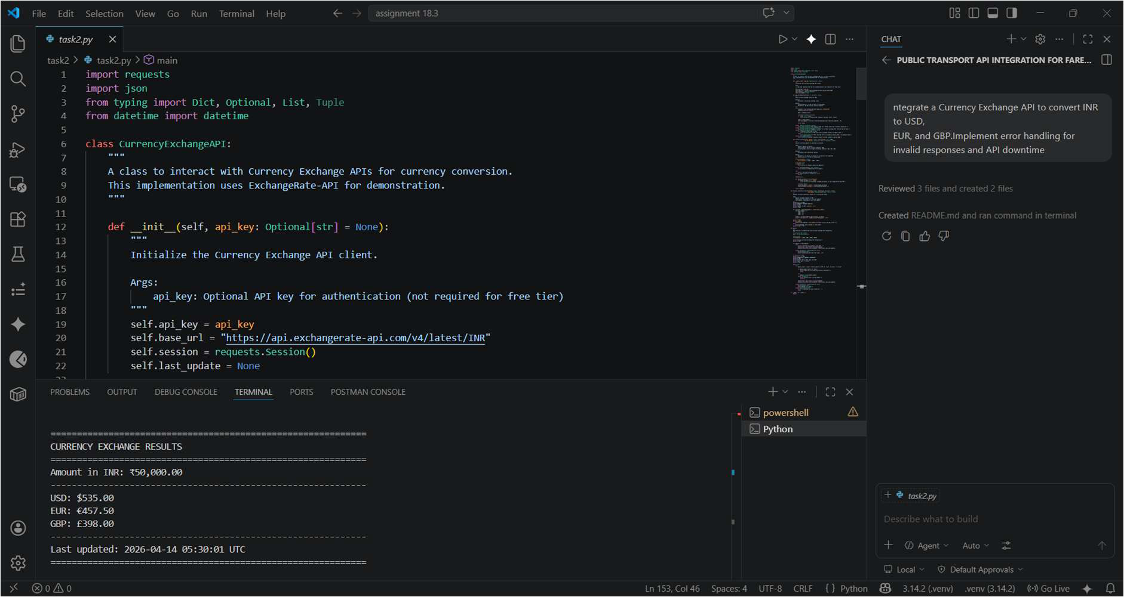
Task 3 – GitHub Repository Info Fetcher
Task:
Connect to the GitHub API to fetch details of a repository (e.g., stars, forks, issues).
Instructions:
• Prompt AI to write a Python function to send GET requests to GitHub API.
• Handle rate limit errors, 404 (repo not found), and invalid input.
• Display repository name, description, stars, forks, and open issues.
Expected Output:
• A Python program that retrieves and displays GitHub repository information with robust error handling.

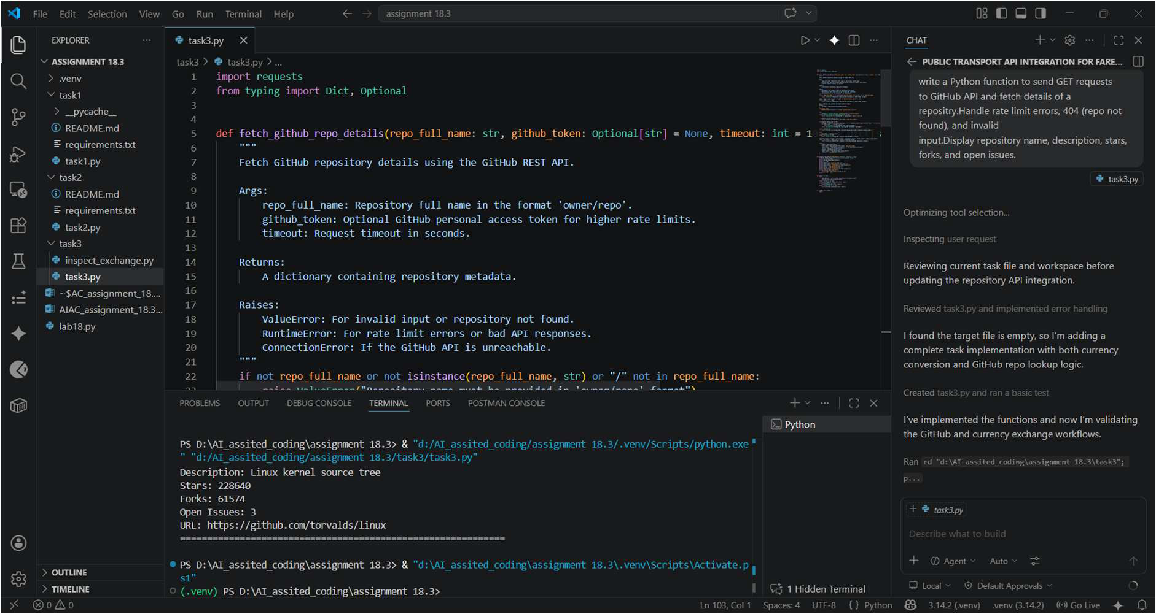
Task 4 – Real-Time Application: News Headlines Aggregator Scenario:
Build a News Aggregator using a free News API.
Requirements:
• Fetch top 5 headlines for a given category (sports, technology, health).
• Handle errors like invalid category, missing API key, and request failures.
• Display headlines in a user-friendly numbered list format. • Include a retry mechanism if the first request fails.
Expected Output:
• A working Python script that retrieves and displays news headlines with proper error handling

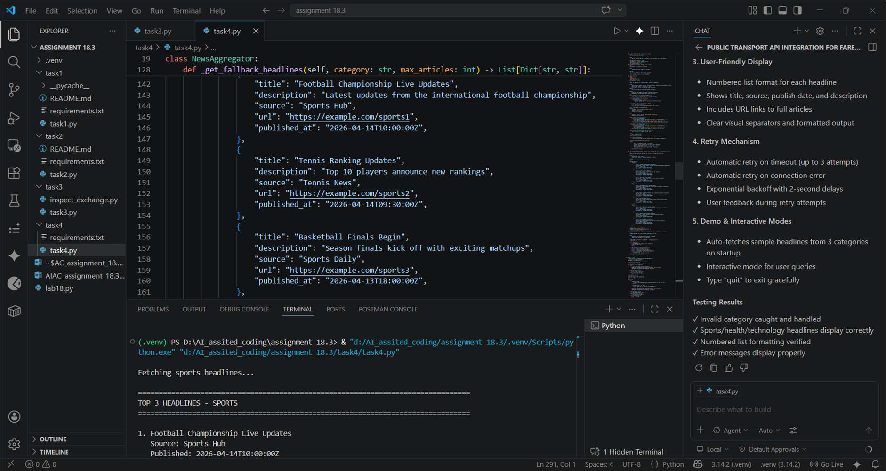
Task 5 -COVID-19 Statistics API Integration
Task:
Connect to a COVID-19 Statistics API to fetch country-wise COVID data.
Instructions:
• Use AI to generate Python code using the requests library • Accept country name as user input
• Fetch key statistics such as:
o Total confirmed cases
o Total deaths
o Total recovered cases
o Active cases
• Handle API errors including:
o Invalid country name
o API rate-limit exceeded
o Network or server failures
• Implement retry or wait logic when rate limits are hit

Expected Output:
A Python program that retrieves and displays country-wise COVID-19 statistics with proper rate-limit handling and error management.
